Exp. 6. Demonstration of Quantum Tunneling
Aim To learn the demonstration of Quantum Tunneling is analysed and the key learning points are observed using nano hub simulation tool
Output:
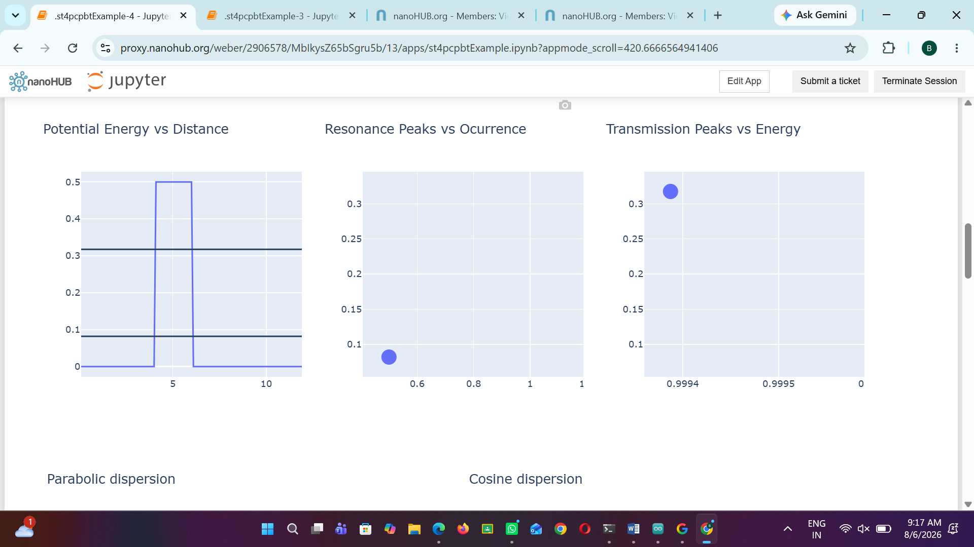
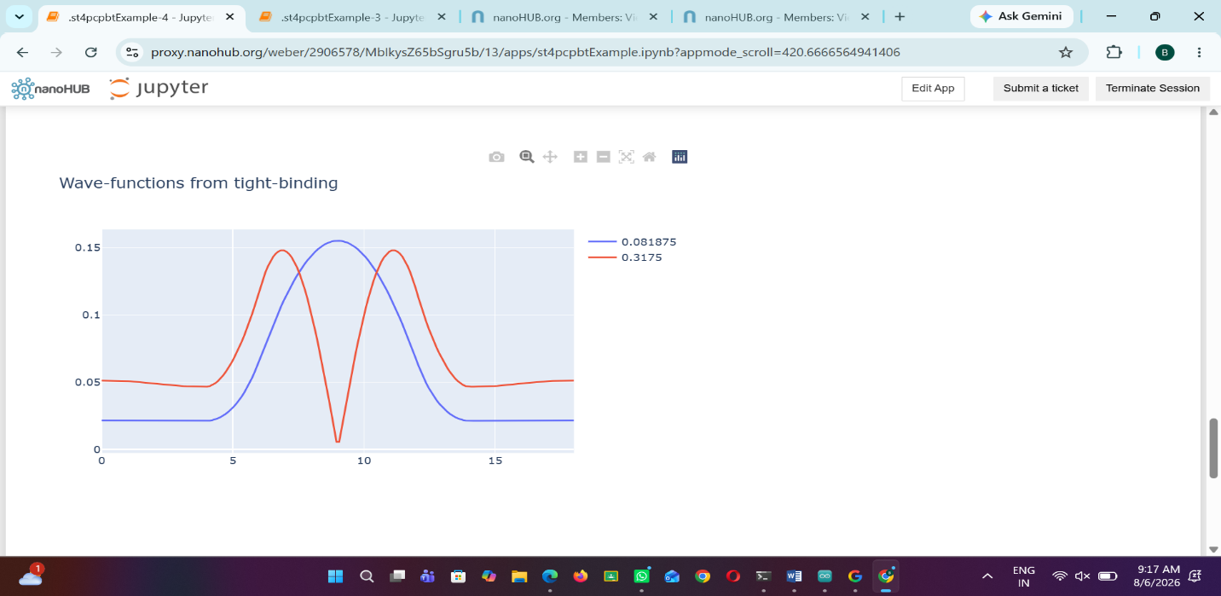

Case study 1 : Analysis the transmission co-efficient Vs Energy characteristics on refined grid

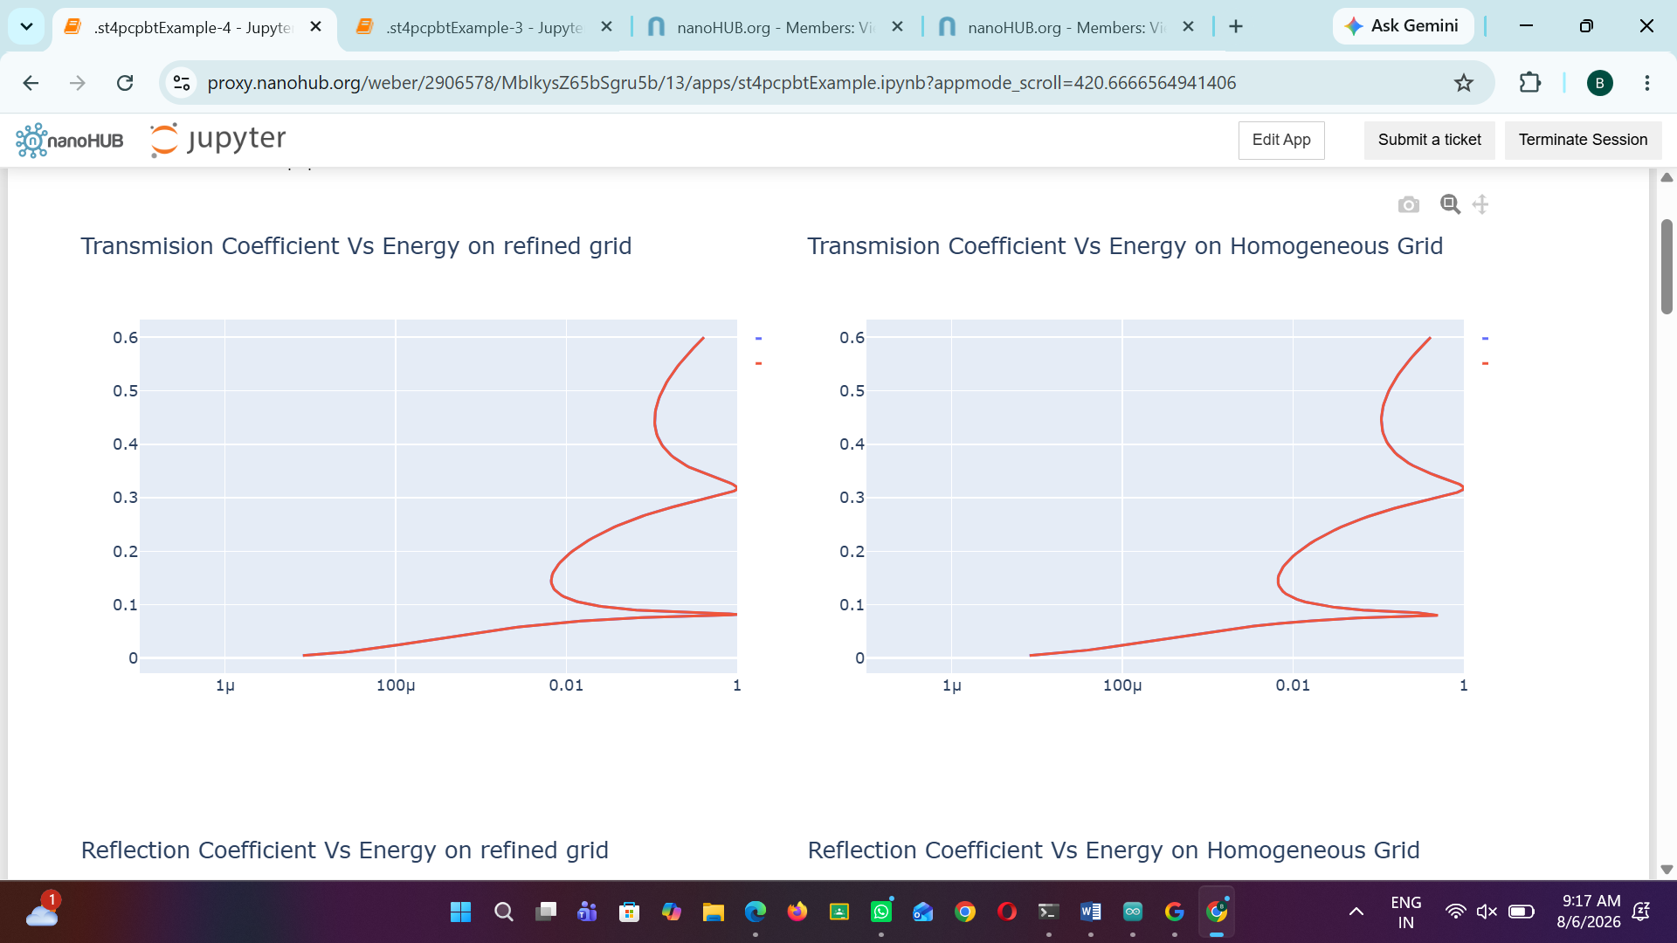
Case study 2 : Analysis the Reflection co-efficient Vs Energy on Homogeneous Grid
